Assignment 9
Consider the following tables namely “DEPARTMENTS” and “EMPLOYEES” Their schemas are as follows,
Departments ( dept no , dept name , dept_location ); Employees ( emp_id , emp_name , emp_salary,dept_no);

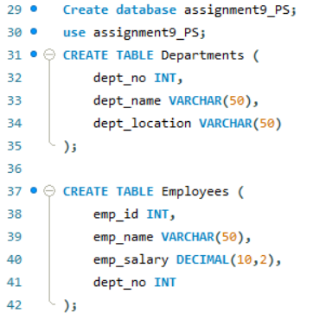

a) Develop a query to grant all privileges of employees table into departments table
b) Develop a query to grant some privileges of employees table into departments table
c) Develop a query to revoke all privileges of employees table from departments table
d) Develop a query to revoke some privileges of employees table from departments table
e) Write a query to implement the save point.
Queries:
